# Bumble’s Bounce Challenge, or

# Web Log Terminal Challenge

The terminal is in the far right of the game. 

Minty Candycane needs to determine the *least* popular browser that contacted her webserver. The access.log file is a standard Apache access log. 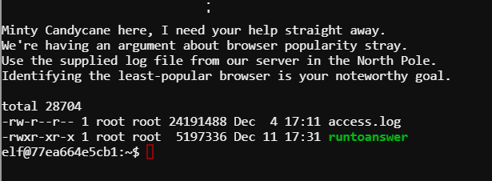

# Hints

Minty Candycane’s tweets give us two interesting links.

<https://pentestarmoury.com/2016/07/26/finding-diamonds-in-the-rough-parsing-for-pentesters-post-1/>

<https://unix.stackexchange.com/questions/170043/sort-and-count-number-of-occurrence-of-lines/263849>

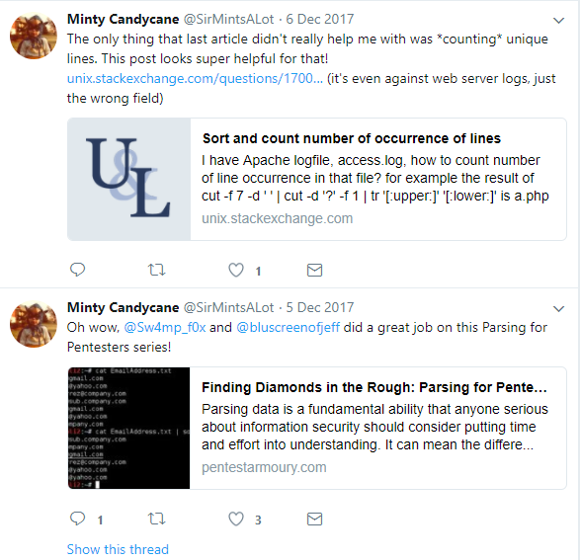

This challenge resembles a Linux lab from the first semester of class. It can be solved using cut, uniq, and sort.

The less command is not available, but more is. It shows the format is:

XX.YY.11.135 - - [19/Nov/2017:08:56:36 -0500] "GET /js/lib/log.js HTTP/1.1" 304 0 "https://www.northpolechristmastown.com/" "Mozilla/5.0 (X11; Linux x86_64; rv:57.0) Gecko

/20100101 Firefox/57.0"

Use cut, with quote (“) as a delimiter, to get to this:

Mozilla/5.0 (X11; Linux x86_64; rv:57.0) Gecko /20100101 Firefox/57.0

Then cut with ) as a delimiter to get

Gecko /20100101 Firefox/57.0

Finally, cut with / as a delimiter to get

Gecko.

Use uniq to remove duplicates, and count the number of occurrences with the -c switch. But, before using uniq, remember that the list first has to be sorted with sort. Finally you can sort by the numbers that the uniq -c command gives you.

Pipe all your cuts, sorts and uniqs together and you can get the answer in a one-liner!

Note: A couple of lines (Plus; Android 7.0 and ; Android 7.0) snuck through my filter. Also, curl and masscan are not browsers.

# Hand in

Hand in the command you used to find the answer.

# Solution

There are many ways to solve this. Here is one. 